Blessed Hands Chiropractic, PLLC
blessedhandschiro@gmail.com

WELCOME! WE ARE SO EXCITED TO HAVE YOU!!!
Patient Name · _____________________ ____ __________________________________ ^{First} ^{MI} ^{Last}
Address · _____________________________________________ _______
^{Street} ^{Apt/Suite}
________________________________________ ______ ______________
^{City} ^{State} ^{Zip}
Best Phone Number to Reach You: ____________________________

Birth Date__________________ Gender M F

Email___________________________________________

Please completely fill out all applicable information

Occupation/ Employer · ______________________________________________________________________

Marital Status · M / S / D / W

Spouse’s Name · ____________________

Parent/ Guardian Name · ___________________________________________ (if under 18)

How did you hear about us?
❑ Friend or Family _____________________ Internet
Booth Ad Other ________________

NOTE: Although Blessed Hands Chiropractic, PLLC will give you all information you need to be reimbursed by your insurance if you have chiropractic benefits, the ultimate financial responsibility remains with you, the patient. By signing this you are consenting to receive chiropractic care.

Patient Signature: _______________________________ Date _________
Patient or Parent/ Guardian Signature (if < 18yr old)

Doctor use ONLY _________________________________________________________________________________________________________________________________________________________________________________________________________________________________________________________________________________________________________________________________________________________________________________________________________________________________________________________________________________________________________________________________________________________________________________________________________________________________________________________________________________________________________________________________________________________________________________________________________________________________________________________________________________________________________________________________________________________________________________________________________________________________________________________________________________________________________________________________________________________________________________________________________________________________________________________________________________________________________________________________________________________________________________________________________
Chief Complaint:___________________________________________
When did this pain first start?_________________________________
Was there an incident that caused this pain?
No Yes(describe)___________________________________________
_________________________________________________________
Have you had this pain before?
No Yes(describe)__________________________________________
Describe the pain (circle all that apply):
Achy Sharp Tight Tingling Burning
Throbbing Numbness Deep Superficial
Pain Scale: 1 2 3 4 5 6 7 8 9 10 (1=very minimal, 10=unbearable)
Does the pain travel? No Yes (where?)_________________________
Worse in (circle): Morning Afternoon Evening Night
Activities that worsen it (circle):
Bending Laying Sitting Standing Walking Running
If other, please describe:______________________________
What seems to make it better?_______________________________
What seems to make it worse?_______________________________
Have you lost sleep due to the pain: No Yes
Have you had any unexplained weight loss recently: No Yes
What activities would you like to get back to that you are currently
unable to enjoy? __________________________________________
_________________________________________________________
Are there other complaints or issues you would like the doctor to
know about? No Yes (describe)______________________________
_________________________________________________________

On the diagram below, using the key, please indicate the location and type of pain/symptoms you are currently experiencing:
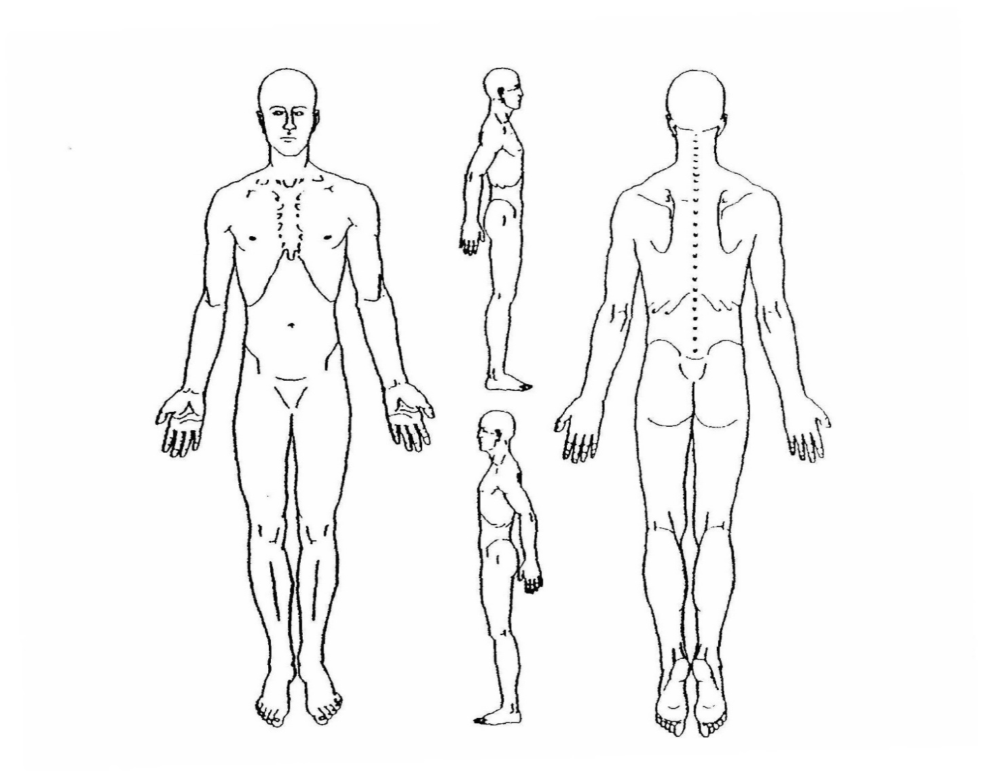

·
·

Patient Signature: _______________________________ Date: ______________

Have you been to a chiropractor before? No Yes, __________________________________ (who, results)

Please List any medications and/or vitamins you currently take: _____________________________________
__________________________________________________________________________________________
__________________________________________________________________________________________

How many servings of fruits and vegetables do you eat per day? 0-2/day 3-6/day 7-10/day

How much water do you drink per day? Minimal Enough A Lot

Would you like nutritional recommendations? Y N

Please circle any conditions that you have had or currently have
Musculoskeletal  Low Back Pain  Joint Pain/Stiffness  Leg Pain  Neck Pain  Mid Back Pain  Muscle weakness  Trouble Swallowing  Fracture/Dislocation  Eye/Ear/Nose/ Throat  Pain in Eyes  Visual Problems  Difficulty Hearing/Deaf  Ringing in Ears  Allergies  Nose Bleeds  TMJ/ Pain in Jaw | Nervous System  Arm Pain Numbness  Headaches  Dizziness  Fainting  Loss of Balance  Seizures  Stroke  Depressions  Paralysis  Cardiovascular  Heart Disease  Edema/Swelling  Pneumonia/ Lung Infection  Fatigue  Wish to Lose Weight | Genito-Urinal  Excessive Urination  Difficult Starting/Stopping  Change in color  Prostate: Last Exam: ___  Discharge  Urinary Tract Infections  Flank/ Pelvic Pain  Birth Control Pills  _______  Change in Sex Drive  Pain During Sex  Gastrointestinal  Disinterest in food  Diarrhea  Constipation  Tummy Aches

Do you or any of your family members have a history of Cancer, Heart Disease, Diabetes, Neurological Disorders (Parents, Grandparents)? ____________________________________________________________
_________________________________________________________________________________________

Any work injuries at any job in the past? No, Yes _________________________________________________

Are you currently under treatment for any work-related injury or other accidents? No, Yes
Is there any chance that you could be pregnant at this time? No, Yes
Do you have any additional concerns that have not been covered in this intake form? ____________________________________________________________________________________________________________________________________________________________________________________
Doctors Notes:
MVA_____________________________________________________________________________________
_________________________________________________________________________________________
_________________________________________________________________________________________
Surgeries _________________________________________________________________________________
_________________________________________________________________________________________
_________________________________________________________________________________________
Fx Dis ____________________________________________________________________________________
_________________________________________________________________________________________
_________________________________________________________________________________________
Illnesses _________________________________________________________________________________
_________________________________________________________________________________________
_________________________________________________________________________________________
Other ____________________________________________________________________________________
_________________________________________________________________________________________
_________________________________________________________________________________________
_________________________________________________________________________________________
_________________________________________________________________________________________
_________________________________________________________________________________________

Thank you so much for filling this out! We are blessed to have you!

No Show/Cancellation Policy

We ask for 24 hours notice if you need to cancel or reschedule your appointment. Last minute changes may incur a $50 charge for the missed appointment or late cancelation. If you need to re-schedule the appointment due to unforeseen circumstances the charge may be waived as long as you call two hours prior to the start of your appointment time and reschedule that appointment. It is important to us that you receive the best care possible, and full body treatments take a certain amount of time. Unfortunately, if you are more than 10 minutes late to your appointment, that will not leave enough time for you to receive quality care and will be considered a missed appointment and you may incur the $50.00 charge.

After 2 missed appointments we will request that you pre-pay for each following appointment.

This is to maximize your treatments, get you better quickly and keep our schedules running smoothly.
Thanks for your understanding and participation.

BHC Staff & Dr. Meagan Svec

Signing this states you have read and agree to comply with the no show policy at Blessed Hands Chiropractic, PLLC. If you wish to have a copy of this notice just ask.

Sign _________________________________ Date ________________________

ACKNOWLEDGE OF RECEIPT OF NOTICE OF PRIVACY PRACTICES

By signing below, I acknowledge that on request I will receive a copy of the current HIPAA form containing Notice of Privacy Practices.

Signature of patient or personal representative _____________________ Date
If signed by personal representative, relationship to patient

Office Use Only:

Our organization has made a good faith effort to obtain a written acknowledgement of receipt of the Notice provided to the individual named below.

Patient name:

Refused to sign Physically unable to sign

(Other)

Employee Signature: Date: _____

